Review Guide Quarterly 2

* We study cells because they tell us about other things
  + Cells- Tissues- Organs- Bodies.
  + We also recognize the limits of cells
* Cells are the basic unit of structure of an organism and function
  + Make energy
    - Need energy, clean up waste, and make energy
  + Make proteins
    - Do all the work in a cell so we need lots of ‘em
  + Make more cells
    - For growth
    - To replace damaged or diseased cells
* Organelles: Each structure has a job.
* Determining Bounds:

Upper- S.A/V. ratio too low; becomes inefficient at transporting substances across membrane and across cell.

Lower- need to big enough to contain the organelles needed for proper functioning

* Cells that make energy:
  + Cell Membrane
  + Lysosome
  + Vacuole and Vesicles
  + Mitochondria
* Cell Membrane:
  + Function: Separates cell from outside, controls what leaves cell.
  + Structure: Semipermeable membrane/ phospholipid bilayer
* Vacuole and Vesicles
  + Function: Move material around cell, store special enzymes
  + Structure: Membrane Sac. Filled with enzymes
* Lysosomes:
  + Function: Digest food. Clean up and recycle
  + Structure: Membrane sac of digestive enzymes.
* Mitochondria:
  + Function: Make ATP energy from cellular respiration
  + Structure: Double membrane (cristae, matrix)
* Nucleus:
  + Function: Control center of cell. Protects DNA from erosion
  + Structure Nuclear membrane, nucleolus, little pit that makes ribosomes.
* Ribosomes:
  + Function: Protein Factories. Read instruction to build proteins
  + Structure: Some free let in cytoplasm. Some attach to the E.R

|  |  |
| --- | --- |
| Eukaryotic cells | Prokaryotic cells |
| Large | Small |
| Diverse | Similar in structure |
| Membrane bound organelles | No membrane bound organelles |
| True (membrane bound) nucleus | No true nucleus (nucleoid region though) |
| Animals, plants, fungi, protists | Eubacteria and archeabacteria |

Simple Diffusion vs. Facilitated Diffusion:

Simple: Nonpolar, Small molecules. Facilitated: Ionic, polar, large molecules with the use of a protein. Both are without energy.

Passive Transport:

*Small, nonpolar molecules pass through the phospholipid bilayer w/o energy or transport energy*

* Diffusion: tendency for particles of any kind to spread out evenly in an available space from more to less concentrated
* Requires no work (No ATP is used up in the process)
* Goes down its concentration gradient
  + Reaches dynamic equilibrium. No net change
* Creates a concentration gradient and diffuses down it.
* In our lungs, diffusion down concentration gradients is the sole means by which oxygen enters red blood cells and carbon dioxide pass them out.
* Osmosis:
  + Most important substance that crosses by passive transport is water.
    - Selectively permeable membrane allows only some to move more easily than others.
  + Moves based on molecules/milliliter of solution are equal.
  + Look at the net flow of the movement
* Ions and polar molcules need transport protiens
* Facilitated diffusions
  + Used for substances that need assistance in order to diffuse
  + Uses a protein to move down its concentration gradient.
  + Number of sugars, amino acids, and ions use it.
    - Even water uses it as its diffusion is relatively slow.
    - Aquaporin are needed to rapidly diffuse them.

Active Transport: Cell must expend its energy in order to move a solute AGAINST its concentration gradient.

* Known the process of a sodium pump.
  + Solute binding
  + Phosphorylation
  + Transport
  + Phosphate Detaches
* Allows cell to maintain concentrations of small molecules that are different from concentrations in its surroundings.

Example of Potassium Sodium Pump:

3Na+ pumped out of cell while 2K+ pumped in. This creates a relatively negative charge on the inside of the membrane and positive charge on the outside. This separation of charges is called resting potential. When the membrane is stimulated gates or channels in the membrane open, allowing the Na+ and K+ to flow back and charges reverse. This is called a stimulus. (Look at the steps)

* Tonicity: Describes the ability of a solution to cause a cell to gain or loose water:
  + Isotonic Same amount of volume. Concentration is equal.
  + Hypotonic Solution: A solution with a solute concentration lower than that of the cell
  + Hypertonic: A solution with a solute with a higher solution concentration
* Animal Cells:
  + Isotonic: Normal
  + Hypotonic: Lysed [High Water]
  + Hypertonic Solution: Shriveled [Low Water]
* Plants Cells:
  + Isotonic: Flaccid
  + Hypotonic: Turgid. This is the ideal state for plants. They have a central vacuole and cell walls which allows them to be strengthened by this
  + Hypertonic: Plasmolysis

Plants Cells vs. Animal Cells:

* Plants have a cell wall, plastids and a central vacuole.
* Animal cells have centrioles and lysosomes
  + Centrioles: Help coordinate cell division. Found as a pair
  + Lysosome: Type of a vesicle that digests food. Structure is a membrane sac of digestive enzymes.
* Plants cells are geometric or square
* Animal cells are diverse in shape and function

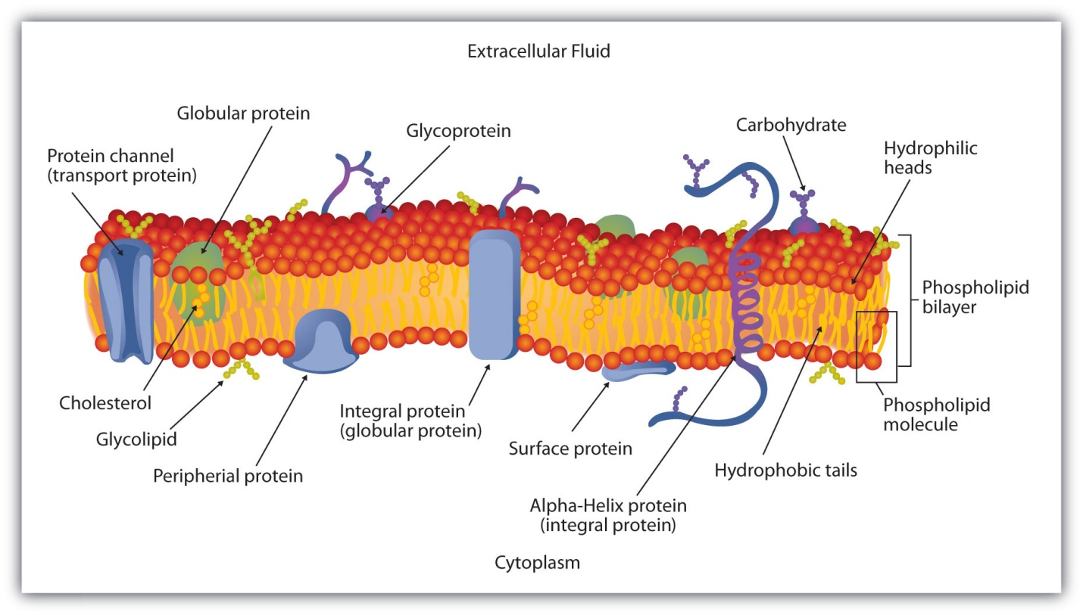

* The Phospholipid Bilayers has two components in it, the hydrophilic “head” and the hydrophobic tail.
  + Unsaturated- Forms kinks that prevent the phospholipids from packaging tightly together
* Carbohydrates: Serve as Cell Identification tags
  + Determine the species, individual cell that it belongs to and type of the cells
* Cholesterol: Wedged into the bilayer and helps stabilize the membrane at warm temperatures. It helps keep the membrane at a low temperature
* Proteins:
  + Peripheral Proteins: Peripheral proteins are attached to the exterior of the lipid bilayer. They are easily separable from the lipid bilayer, able to be removed without harming the bilayer in any way. Peripheral proteins are less mobile within the lipid bilayer.
  + Integral: Gives membrane strong “framework”. Attaches to the cytoskeleton on inside and extra-cellular matrix on the outside.
  + Glycoprotiens: Cell-cell recognition, a second function of plasma membrane protiens.

How are directions sent:

* DNA sends instructions via Messanger RNA to a ribosome (protein builder).
* Instructions interpreted into polypeptide.
* Processed and packaged by the R.E.R
* Golgi Body processes and repackages as a protein..
* It pops out in a vesicle, travels to the cell membrane; fuses then gets released outside the cell. It is now on its way to some target tissue or organ in the body.

Equation for Cellular Respiration:

Glucose + 602 – 6CO2 + 6H20 + ATP

Aerobic Basic Ideas:

* Glycolysis: Breaking down of glucose into 2, 3- Cabron rings called Pyruvate
* Kreb: Decomposing of pyruvate to C02.
* Oxidative Phospho: Inovlves the ETC and a process known as chemiosmosis. Most of the ATP is produced here
  + ATP Synthase: Protien that behaves like an engine. Chemiosmosis provides it the H+ it needs to turn the ADP into ATP

Pyruvate is made into Acetyl Co-A

* Acetyl CoA: Carboxyl group is removed from pyruvate and the remaining joins with a coenzyme A.
* NAD+ is reduced to NADH + H+

Payoff Results / glucose molecule.

ATP NADH FADH2 Location

1. Glycolysis 2 2 0 cytoplasm
2. Conversion 0 2 0 matrix

Acetyl CoA

1. Kreb Cycle 2 6 2 matrix
2. O. P. 34 0 0 crista

Comparing Lactic Acid Fermentation, Alchoholic {Anaerobic} with Aerobic:

Aerobic respiration lactic acid fermentation alcohol ferm.

Uses oxygen no oxygen used no oxygen

Glycolysis, Kreb, O.P. Glycolysis only glycolysis only

Needs mitochondria mitochondria not used mito. not used

36-38 ATP made 2 ATP and lactic acid made 2 ATP, CO2

and ethanol made